**Maryland Department of Agriculture Spay and Neuter Grants Program**

**2019 FERAL CAT-FOCUSED APPLICATION**

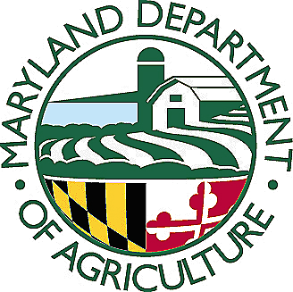

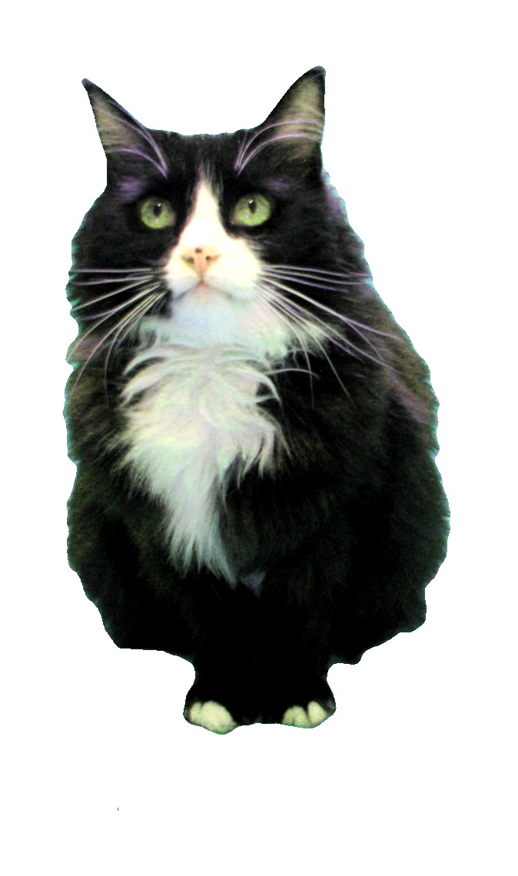

The following application form is used for projects that focus on **feral cats and training**. Projects with focus on pets or for capital expense/equipment request need to use the Pet-Focused Application form or the Capital Expense/Equipment Application form. Applicants seeking funds to spay/neuter feral cats should be aware of the following criteria and requirements:

* Municipal or county governments or non-profit animal welfare organizations with tax exempt status under 501 (c)(3) are eligible to apply to facilitate and promote the provision of spay and neuter services for feral cats.
* A **competitive** grant proposal:

-May target feral cat populations if the department determines that this targeting does not violate local law.

-May include public education and outreach components.

Also-

Grant projects must meet the purpose of the Fund. Grant projects that most effectively and efficiently facilitate, promote and increase spay and neuter services for feral cats in Maryland will be given priority.

Applicants must comply with all other statutory and regulatory requirements pertaining to the Spay/Neuter grant program.

* Applicants should familiarize themselves with those provisions of the Maryland Code. [Program Regulations](http://www.dsd.state.md.us/comar/SubtitleSearch.aspx?search=15.01.10)
* Projects must not target feral cats on lands managed by Department of Natural Resources (DNR) or Maryland Park Service (MPS).
* Projects may not occur on or immediately adjacent to lands with protected species or sensitive resources managed by DNR or MPS.
* Applicants must have signed consent from landowners (or their authorized representatives) or legal tenants for those areas where feral cats will be trapped, returned or where personnel must enter to set and access target cats.
* Applicants must employ responsible methodologies that safeguard the wellbeing of the cats but also other wildlife and the public. MDA will only support those organizations that seek to ultimately decrease the populations of feral cats. MDA will not support any individual or organization that intends to increase feral cat populations or release more cats into the wild.
* Applicants shall coordinate with local animal control and shelter staff to confirm their project would impact intake and euthanasia.
* The Applicant and personnel who will work on the project must have the qualifications and resources (reflected in the application) necessary to perform and complete the work proposed in the application.
* Applicants who conduct spay/neutering using other funds should provide a “net increase” in surgeries. These funds cannot be used to maintain the organization’s status quo or replace other funds.
* Applicants and their organizations should have no history of violations or fines with Maryland Animal Control authorities and any history of violations may be a basis for denying funding.
* Applicants must be in good standing with the State of Maryland.
* Applicants with shelters must be in compliance with the Standards of Care requirements set forth by Sections 2-1701 through 2-1705 under Subtitle 17, Animal Shelters, in the Agricultural Article of the Annotated Code of Maryland.
* Applicants must complete and submit the grant application, with any required attachments as specified in the 2019 Instructions for Feral Cat Focused Applications and on the application forms by close of business (5:00 PM EST) on or before the posted grant deadline as it appears on the Request for Proposals (RFP) and on the MDA website ([Spay and Neuter Grants Program webpage](http://mda.maryland.gov/spay_neuter_program/Pages/default.aspx)).

**REVIEW THE INSTRUCTIONS BEFORE STARTING THIS APPLICATION.**

**READING AND ADHERING TO THE INSTRUCTIONS DOCUMENT IS CONSIDERED A REQUIREMENT OF THE APPLICATION PROCESS.**





**MARYLAND DEPARTMENT OF AGRICULTURE**

**SPAY AND NEUTER GRANTS PROGRAM**

**2019 FERAL CAT-FOCUSED APPLICATION FORM**

The purpose of the program is to reduce animal shelter overpopulation and cat and dog euthanasia rates by financing grants to local government facilities and animal welfare organizations for programs that most efficiently and effectively facilitate and promote the provision of spay and neuter services for cats and dogs in the State.

**All fields are MANDATORY**. Application fields left blank may cause your application to be deemed incomplete and ineligible for further consideration. Any fields that are not applicable to your application should be indicated by entering “N/A”. The text fields in this form will expand as you enter your narrative. You may also attach extra page(s) if necessary.

**Please carefully proofread all of your text and check your math before submitting your application.**

|  |  |  |  |  |  |  |  |  |  |  |  |  |  |
| --- | --- | --- | --- | --- | --- | --- | --- | --- | --- | --- | --- | --- | --- |
| **A. PROPOSAL ADMINISTRATION INFORMATION** | | | | | | | | | | | | | |
| **Title of Proposed Project:** | | | | | | | | | | | **(for MDA use only)**  **Proposal Ref Number:** | | |
| **Total Amount Requested (No less than $5,000): $** | | | | | | | | | | |
| **Name of Requesting Organization(s):** | | | | | | | **Address, City, State, Zip Code:** | | | | | | |
| **Phone | Fax of Applying Organization****Phone:**  **Fax:** | | | | | | | **Website Address, if any:** | | | | | | |
| MDA Spay and Neuter Grants Program Criteria and Requirements**By checking the following appropriate boxes, the applicant certifies that the applicant meets our program basic criteria and requirements.****CHECK:**  **The Applicant has read and adhered to the 2019 Instructions for Feral Cat-Focused Applications.**  **AND:**  **Being a Municipal or County Government, OR**  **Being a Private Organization contracted by a county to provide animal services, OR**  **Being an Animal Welfare Organization with tax exempt status under 501 (c) (3). If so, please attach a PDF of your most current IRS Form 990 if applicable.**  **AND:**  **Does not violate any county laws regarding feral cats and does not occur on lands managed by the Department of Natural Resources.**  **Being an Applicant that is in good standing with the State of Maryland.**  **If the Applicant shelters animals, the Applicant is in compliance with Standards of Care requirements of Sections 2-1701 through 2-1705, Subtitle 17, Animal Shelters, in the Agricultural Article of the Annotated Code of Maryland.**  **Applicant guarantees that their project personnel or organization has no history of fines or violations with any Maryland Animal Control Authorities or if so has clarified the matter with MDA prior to submittal.** | | | | | | | | | | | | | |
| **Make sure all the above boxes are addressed accurately before proceeding** | | | | | | | | | | | | | |
| **B. POINT OF CONTACT & ORGANIZATION INFORMATION** | | | | | | | | | | | | | |
| **Primary Point of Contact (POC):** | | | | | | **Financial Point of Contact (FPOC):** | | | | | | | |
| **Title:** | | | | | | **Title:** | | | | | | | |
| **Phone (and ext. if applicable):** | | | | | | **Phone (and ext. if applicable):** | | | | | | | |
| **Email:** | | | | | | **Email:** | | | | | | | |
| **Employer Identification Number:** | | | | | | | | | | | | | |
| **Applying Organization:** **Number of Staff:**  **Number of Volunteers:**  **Briefly describe your organization (i.e. when established, # of animals you typically intake in a quarter, the area(s) you service, etc.) Only include information pertinent to the work you are proposing in this application:**    **Operating Budget for 2018: $****Operating Budget for 2017: $**  **Number of low or no cost spay/neuter procedures your facility/organization has provided or facilitated each year for the last 3 years:**  **# of procedures for 2016:       # of procedures for 2017:       # of procedures for 2018:**  **If the number of surgeries your organization has facilitated has decreased from previous years, please explain why:** | | | | | | | | | | | | | |
| **Summarize any grants your organization has received in the last 3 years, including grants from MDA (Be brief: From whom, how much, what was accomplished and where):** | | | | | | | | | | | | | |
| **Are you applying for another grant from this Program for this cycle? Please CHECK appropriate box.**  **NO, this is our only application for this cycle. Proceed to Section C.**  **YES, we are submitting a second application to this program for this cycle.**  **IF YES: Please confirm that your organization has the capacity to perform all the tasks for all the applications proposed:**    **If your 2 applications are related to the same project, please state whether your organization has the capacity and resources to move forward with the project if MDA recommends funding one of your applications but not the other:**    **If your 2 applications are independent from each other, please indicate which application you feel should have priority if the Program can only fund one of your applications:** | | | | | | | | | | | | | |
| **Please be sure to submit your organization’s most recent IRS 990 if required by IRS.** | | | | | | | | | | | | | |
| **C. PROJECT DETAILS** | | | | | | | | | | | | | |
| **C-1- Period of Performance: Give the start date and end date to your project (month and year). A project should be no more than 12 months: Start:**   **End:** | | | | | | | | | | | | | |
| **C-2- Project Description:** **Describe what you propose to do with the grant. This should be a brief summary (several paragraphs only). The details should be provided in subsequent sections of the application form:** | | | | | | | | | | | | | |
| **C-3-Target Information** | | | | | | | | | | | | | |
| **C-3-A-Target Area: Identify the location (target area or cat colonies) of your project. Explain how you determined that this area or colonies has a significant population of unaltered feral cats that impact a shelter or shelters listed in C-3-B.** | | | | | | | | | | | | | |
| **C-3-B-Shelter Statistics Provide the intake and euthanasia numbers for the last 3 years for any shelter in your target area. Include stats from any shelter that may directly benefit from your project outside of your county. Add a page if more space is needed. Dog information is not mandatory for this application category.** | | | | | | | | | | | | | |
| **Shelter Name and County:** | | | | | | | | | | | | | |
|  | **Total Intake for: 2016/2017/2018** | | | | | | | **Total Euthanasia for: 2016/2017/2018** | | | | | |
| **Cats** | **/       /** | | | | | | | **/       /** | | | | | |
| **Dogs** | **/       /** | | | | | | | **/       /** | | | | | |
| **2nd Shelter Name and County (if applicable):** | | | | | | | | | | | | | |
| **Cats** | **/       /** | | | | | | | **/       /** | | | | | |
| **Dogs** | **/       /** | | | | | | | **/       /** | | | | | |
| **Additional Data: If you were able to obtain any additional data drilled down to your specific target area (by zip code, neighborhood, etc) please provide information here. Also use this space, if necessary, to provide any additional data you may have from other sources:** | | | | | | | | | | | | | |
| **C-3-C-Target Number of Surgeries: This number must match the number in Budget Line Items Veterinary Services.** | | | | | | | | | | | | | |
| **# Cat Spays:** | | **Cost/Spay: $** | | | **# Cat Neuters:** | | | | | **Cost/Neuter: $** | | | |
| **Discuss estimated number of unaltered feral cats for the area, any colony-specific information and how you came to choose your target number of surgeries above, including the use of Feral Cat Estimation Tool or use of the “Divide by 15” rule:** | | | | | | | | | | | | | |
| **Target Information Required Attachments:**  **CHECK: I have included the required map with my application, indicating where the project target area is located.**  **CHECK: I have included copies of the all or most of the required Permission Forms**  **OR**  **CHECK: I have made contact with all or the majority of Property Owners/Legal Tenants and will be able to secure the forms if funded.** | | | | | | | | | | | | | |
| **C-3-D-Expected ImpactS: Detail how each shelter listed in Section C-3-C will benefit from this project and to what extent (numbers reduced, percent reductions, etc.) you anticipate your project will impact shelter intake and euthanasia:** | | | | | | | | | | | | | |
| **C-4-Partnering: List the organization name, a brief description of their expertise, and what part they will serve in the project (list financial contributions in Section D-3. below):** | | | | | | | | | | | | | |
| **C-5-A-Detailed Work Plan: Describe in a step by step timeline the activities and/or tasks that will be performed to accomplish the objectives of the project:** | | | | | | | | | | | | | |
| **C-5-B-Project Methods AND STRATEGIES: Detail the methods and strategies that will be used in this project. Include discussion on plans for collecting, transport, evaluating for re-homing efforts, and returning:** | | | | | | | | | | | | | |
| **C-6-Outreach Plan: Detail your outreach plan and how you will communicate about your project to gain support from the local community and caregivers. If signage is proposed, provide a draft of the text to be used:** | | | | | | | | | | | | | |
| **C-7-Project Support: Discuss and attach copies of any endorsements you have obtained or sought from animal control, local shelters, government agencies, and other animal welfare organizations that may benefit from your project:** **CHECK: Copies of all Letters or e-mails of Support and Endorsement, or documentation of coordination attempts are included with the application.** | | | | | | | | | | | | | |
| **C-8-KEY PERSONNEL: List the key personnel (excluding veterinary staff which should be detailed in Section C-9 below), qualifications, and the kind of task(s) he/she will perform:** | | | | | | | | | | | | | |
| **C-9-Veterinarian Practice/Clinic Capacity: List the veterinarian(s) or clinic(s) you propose to use for your project and confirm that you have discussed this proposal with the veterinarian or clinic with regards to their capacity to perform the number of procedures you propose should you be funded:** **CHECK: Our veterinarian/clinic has the capacity to perform these procedures in within the period of performance.**  **List the full name of the veterinarian(s) and clinic(s) you plan to use. Please include current Maryland license**  **number(s):** | | | | | | | | | | | | | |
| **D. BUDGET AND ADDITIONAL FUNDS INFORMATION** | | | | | | | | | | | | | |
| **D-1-Budget Line Items: Refer to *Instructions for Feral Cat-Focused Applications* for information on allowable expenses and how to describe them. Incomplete or vague budget items will not be considered and may be a basis for downgrading the application.** | | | | | | | | | | | | | |
| **Type** | | | **Description** | | | | | | | | | **TOTAL AMOUNT** | |
| **Veterinary Services** | | | **Cost/cat spay: $****| # spays proposed:** | | | | | | | | | **$** | |
| **Veterinary Services** | | | **Cost/ cat neuter: $      | # neuters proposed:** | | | | | | | | | **$** | |
| **Rabies Vaccine**  **(maximum allowable: $5/dose)** | | | **Number of doses:       Cost/Dose: $** **CHECK here ONLY IF the cost for rabies vaccinations is coming from another source or is part of the Veterinary Services and so is not being requested separately in this application. If the cost is donated, list as a cost- sharing item. (See Section E.)** | | | | | | | | | **$** | |
|  | | |  | | | | | | | | | **$** | |
|  | | |  | | | | | | | | | **$** | |
|  | | |  | | | | | | | | | **$** | |
|  | | |  | | | | | | | | | **$** | |
|  | | |  | | | | | | | | | **$** | |
| **DOUBLE CHECK your calculations and totals. Make sure your totals match the amount requested in Section A** | | | | | | | | | **TOTAL REQUEST** | | | **$** | |
| **Attach pages if more space is required. Include vendor quotes for equipment.** | | | | | | | | | | | | | |
| **D-2-A-Budget Items Justifications: List your budget items greater than $500.00 (excluding surgical costs and rabies vaccinations-these generally do not require justification-see Instructions for more specific information). Trap requests need to be discussed separately in Section D-2-B:** | | | | | | | | | | | | | |
| **D-2-B –Trap Request Justifications: If you have a budget line item for trap costs, please detail here:****# Traps you current own or have ready access to (number and type):** **# Traps needed for this project (number and type):****Additional Information: What steps have you taken to obtain or borrow traps from other sources (example: trap banks, other similar organization to yours, etc.) before making this request. If you are requesting special traps, such as fat cat traps, please explain why:** | | | | | | | | | | | | | |
| **D-3-COST SHARING OR IN-KIND CONTRIBUTIONS: Attach additional pages if more space is needed.** | | | | | | | | | | | | | |
| **Organization** | | | | **Description** | | | | | | | | | **Est.**  **Value** |
|  | | | |  | | | | | | | | | **$** |
|  | | | |  | | | | | | | | | **$** |
|  | | | |  | | | | | | | | | **$** |
| **TOTAL** | | | | | | | | | | | | | **$** |
| **D-4-Matching Grants/Funding: If this project is dependent on another grant or additional funding from either this program or another source, please discuss here. Please give details and provide copies of documentation (including the amount of additional requested funding, funding source, any requirements or parameters related to that additional funding source, and whether the funds have already been secured):** | | | | | | | | | | | | | |
| **Final Acknowledgements** | | | | | | | | | | | | | |
| **CHECK:** **The Applicant reviewed and adhered to the 2019 Instructions for Feral Cat-Focused Applications.**  **All fields in this application have been filled in. Any field not applicable to this application is indicated by the entry “N/A”. The Applicant understands that blank fields may be construed missing information and the application may be considered incomplete and removed from further consideration on this basis.**  **To the best of the Applicant’s knowledge all information provided in this application is true and accurate.**  **The Applicant understands that requiring payments (“co-pays”) for any service covered under this grant is not allowed.**  **The Applicant has included the supplemental information. This includes required items: the Price Assurance Statement from the veterinarian(s) and or clinic(s), copy of most recent 990 (if applicable), map(s), Available Permission Forms, Standards of Care Plan (if applicable), price quote for equipment or other large expenses over $500.00 (if applicable), , and any letters or emails of support from Animal Control/Shelter personnel and/or other government agency.**    **Name of Submitter:** **Date Submitted:**  **SUBMIT completed applications and attachments before the close of business (5:00 PM EST) as per the date stated in the RFP. Submit as an email attachment to:** [**mda.spayandneuter@maryland.gov**](mailto:mda.spayandneuter@maryland.gov)**. Applications submitted to any other email address, faxed or mailed will not be accepted. Once submitted, changes are not permitted. If you have any questions, please contact the Program Coordinator as listed on the Program webpage or call MDA Spay and Neuter Program 410-841-5766.** | | | | | | | | | | | | | |