**Maryland Department of Agriculture Spay and Neuter Grants Program**

**2019 PET-FOCUSED APPLICATION**



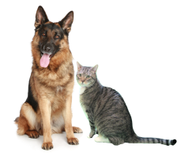

The following application form is used for projects that focus on pet dogs and cats and training. Projects with the focus on feral cats or for capital expense/equipment request need to use the Feral Cat-Focused Application form or the Capital Expense/Equipment Application form. Applicants seeking funds to spay/neuter pet cats and dogs should be aware of the following criteria and requirements:

* Municipal or county governments or non-profit animal welfare organizations with tax exempt status under 501 (c)(3) are eligible to apply to facilitate and promote the provision of spay and neuter services for cats and dogs.
* This is a **competitive** grant proposal that according to the legislation:

-Shall target low–income communities and populations to the maximum extent possible and detail how that goal is to be accomplished;

-Shall efficiently and effectively facilitate and promote and increase the provision of spay and neuter services for cats and dogs; and

-May include public education and outreach components.

* Grant projects must meet the purpose of the Fund. Grant projects that most effectively and efficiently facilitate, promote and increase spay and neuter services for cats and dogs for low income Marylanders will be given priority.
* Applicants must comply with all other statutory and regulatory requirements pertaining to the Spay/Neuter grant program. Applicants should familiarize themselves with those provisions of the Maryland Code. [Program Regulations](http://www.dsd.state.md.us/comar/SubtitleSearch.aspx?search=15.01.10)
* The Applicant and personnel who will work on the project must have the qualifications and resources (reflected in the application) necessary to perform and complete the work proposed in the application.
* Applicants that conduct spay/neutering using other funds should provide a “net increase” in surgeries. These funds cannot be used to maintain the organization’s status quo or replace other funds.
* Applicants and their organizations should have no history of violations or fines with Maryland Animal Control authorities and any history of violations may be a basis for denying funding.
* Applicants shall coordinate with local animal control and shelter staff to confirm their project would impact intake and euthanasia.
* Applicants must be in good standing with the State of Maryland.
* Applicants with shelters must be in compliance with the Standards of Care requirements set forth by Sections 2-1701 through 2-1705 under Subtitle 17, Animal Shelters, in the Agricultural Article of the Annotated Code of Maryland.
* Applicants must submit the grant application, with any required attachments as specified in the Instructions and on the application form by close of business (5:00 PM EST) on or before the posted deadline as it appears on the Request for Proposals (RFP) and on the MDA website ([Spay and Neuter Grants Program webpage](http://mda.maryland.gov/spay_neuter_program/Pages/default.aspx)).

**REVIEW THE INSTRUCTIONS BEFORE STARTING THIS APPLICATION.**

**READING AND ADHERING TO THE INSTRUCTIONS DOCUMENT IS CONSIDERED A REQUIREMENT OF THE APPLICATION PROCESS.**

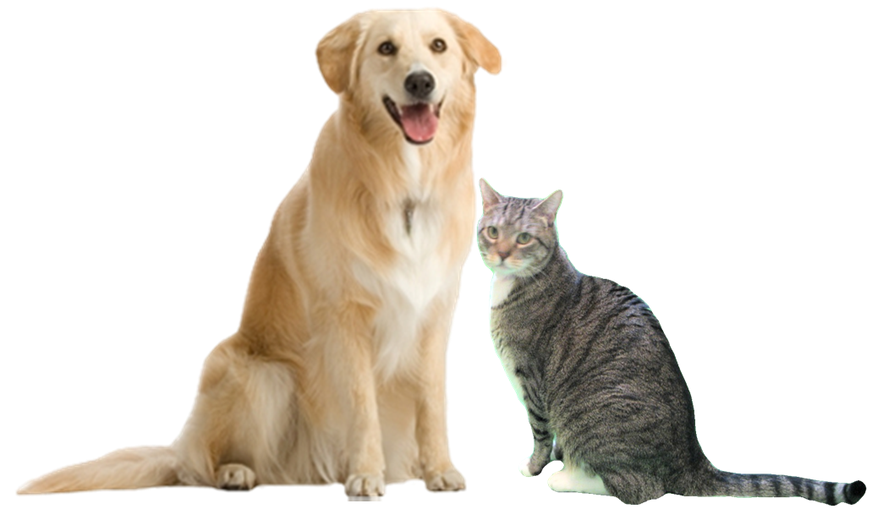



**MARYLAND DEPARTMENT OF AGRICULTURE**

**SPAY AND NEUTER GRANTS PROGRAM**

**2019 PET-FOCUSED APPLICATION FORM**

The purpose of the program is to reduce animal shelter overpopulation and cat and dog euthanasia rates by financing grants to local government facilities and animal welfare organizations for programs that most efficiently and effectively facilitate and promote the provision of spay and neuter services for cats and dogs in the State.

**All fields are MANDATORY**. Application fields left blank may cause your application to be deemed incomplete and ineligible for further consideration. Any fields that are not applicable to your application should be indicated by entering “N/A”. The text fields in this form will expand as you enter your narrative. You may also attach extra page(s) if necessary.

**Please carefully proofread all of your text and check your math before submitting your application.**

|  |  |  |  |  |  |  |  |  |  |  |  |  |
| --- | --- | --- | --- | --- | --- | --- | --- | --- | --- | --- | --- | --- |
| **A. PROPOSAL ADMINISTRATION INFORMATION** | | | | | | | | | | | | |
| **Title of Proposed Project:** | | | | | | | | | | | **(for MDA use only)**  **Proposal Ref Number**  [Prof ref] | |
| **Total Amount Requested (No less than $5,000): $** | | | | | | | | | | |
| **Name of Requesting Organization(s):** | | | | | | | **Address, City, State, Zip Code:** | | | | | |
| **Phone | Fax of Applying Organization** **Phone:**  **Fax:** | | | | | | | **Website Address, if any:** | | | | | |
| MDA Spay and Neuter Grants Program Criteria and Requirements**By checking the following appropriate boxes, the applicant certifies that the applicant meets our program basic criteria and requirements.****CHECK:**  **The Applicant has read and adhered to the 2019 Instructions for Pet-Focused Applications.**  **AND:**  **Being a Municipal or County Government, OR** **Being a Private Organization contracted by a county to provide animal services, OR** **Being an Animal Welfare Organization with tax exempt status under 501 (c) (3). If so, please attach a PDF of your most current IRS Form 990 if applicable.****AND:** **Being an Applicant that is in good standing with the State of Maryland.** **If the Applicant shelters animals, the Applicant is in compliance with Standards of Care requirements of Sections 2-1701 through 2-1705, Subtitle 17, Animal Shelters, in the Agricultural Article of the Annotated Code of Maryland.** **Applicant guarantees that their project personnel or organization has no history of fines or violations with any Maryland Animal Control Authorities or if so has clarified the matter with MDA prior to submittal.** | | | | | | | | | | | | |
| **Make sure all the above boxes are addressed accurately before proceeding** | | | | | | | | | | | | |
| **B. POINT OF CONTACT & ORGANIZATION INFORMATION** | | | | | | | | | | | | |
| **Primary Point of Contact (POC):** | | | | | | **Financial Point of Contact (FPOC):** | | | | | | |
| **Title:** | | | | | | **Title:** | | | | | | |
| **Phone (and ext. if applicable):** | | | | | | **Phone (and ext if applicable):** | | | | | | |
| **Email:** | | | | | | **Email:** | | | | | | |
| **Employer Identification Number:** | | | | | | | | | | | | |
| **Applying Organization: Number of Staff:**  **Number of Volunteers:** **Briefly describe your organization (i.e. when established, # of animals you typically intake in a quarter, the area(s) you service, etc.) Only include information pertinent to the work you are proposing in this application:****Operating Budget for 2018: $****Operating Budget for 2017: $****Provide the number of low or no cost spay/neuter procedures your facility/organization has provided or facilitated each year for the last 3 years:** **# of procedures for 2016:       # of procedures for 2017:       # of procedures for 2018:****If the number of surgeries your organization has facilitated has decreased from previous years, please explain why:** | | | | | | | | | | | | |
| **Summarize any grants your organization has received in the last 3 years, including grants from MDA (you should be brief: From whom, how much, what was accomplished and where):** | | | | | | | | | | | | |
| **Are you applying for another grant from this Program for this cycle? Please CHECK appropriate box.**  **NO, this is our only application for this cycle. Proceed to Section C.**  **YES, we are submitting a second application to this program for this cycle.****IF YES: Please confirm that your organization has the capacity to perform all the tasks for all the applications proposed:**   **If your 2 applications are related to the same project, please state whether your organization has the capacity and resources to move forward with the project if MDA recommends funding one of your applications but not the other:**  **If your 2 applications are independent from each other, please indicate which application you feel should have priority if the Program can only fund one of your applications:** | | | | | | | | | | | | |
| **Please be sure to submit your organization’s most recent IRS 990 if required by IRS.** | | | | | | | | | | | | |
| **C. PROJECT DETAILS** | | | | | | | | | | | | |
| **C-1- Period of Performance: Give the start date and end date to your project (month and year). A project should be no more than 12 months: Start:** **End:** | | | | | | | | | | | | |
| **C-2-Project Description: Describe what you propose to do with the grant. This should be a brief summary (several paragraphs only). The details should be provided in subsequent sections of the application form.** | | | | | | | | | | | | |
| **C-3-TARGET INFORMATION** | | | | | | | | | | | | |
| **C-3-A-Target Area: Identify the location (target area or population) of your project. Explain how you determined that this area or population meets the criteria of “low income” and has a significant population of unaltered dogs and/or cats. Also include a discussion on how your target area is a source of intake to local shelters. Please include all zip codes that occur in your target area.** | | | | | | | | | | | | |
| **C-3-B-Shelter Statistics: Provide the intake and euthanasia numbers for the last 3 years for any shelter in your target area. Include stats from any shelter that may directly benefit from your project outside of your county. Add a page if more space is needed.** | | | | | | | | | | | | |
| **Shelter Name and County:** | | | | | | | | | | | | |
|  | **Total Intake for: 2016/2017/2018** | | | | | | | **Total Euthanasia for: 2016/2017/2018** | | | | |
| **Cats** | **/       /** | | | | | | | **/       /** | | | | |
| **Dogs** | **/       /** | | | | | | | **/       /** | | | | |
| **2nd Shelter Name and County (if applicable):** | | | | | | | | | | | | |
|  | **Total Intake for: 2016/2017/2018** | | | | | | | **Total Euthanasia for: 2016/2017/2018** | | | | |
| **Cats** | **/       /** | | | | | | | **/       /** | | | | |
| **Dogs** | **/       /** | | | | | | | **/       /** | | | | |
| **If you were able to obtain any additional data drilled down to your specific target area (by zip code, neighborhood, etc) please provide information here. Also use this space, if necessary, to provide any additional data you may have from other sources.** | | | | | | | | | | | | |
| **C-3-C-Target Number of Surgeries: This number must match the number in Budget Line Items Veterinary Services. Enter N/A if not applicable.** | | | | | | | | | | | | |
| **# Dog Spays:** | | **Cost/ Dog Spay: $** | | | **# Dog Neuters:** | | | | **Cost/ Dog Neuter: $** | | | |
| **# Cat Spays:** | | **Cost/ Cat Spay: $** | | | **# Cat Neuters:** | | | | **Cost/ Cat Neuter: $** | | | |
| **Discuss estimated number of unaltered pets for the area and how you came to choose your target number of surgeries above, including the use of Pet Estimate Tool):** | | | | | | | | | | | | |
| **Target Information Required Attachments:** **CHECK: I have included the required map with my application, indicating where the project target area is located.** **CHECK: I have included a copy of the Pet Estimate Tool page we used to calculate number of unaltered pets in our target area(s).** | | | | | | | | | | | | |
| **C-3-D-Expected Impacts: Detail how each shelter you listed above will benefit from your project and to what extent (numbers reduced, percent reductions, etc.) you anticipate your project will impact shelter intake and euthanasia:** | | | | | | | | | | | | |
| **C-4-Partnering: If your project involves partnering with another organization (an organization that will contribute but not share in the grant funds) list the organization name, a brief description of their expertise, and what part they will serve in the project (any financial contributions from partners should be listed in Section D-3. below):** | | | | | | | | | | | | |
| **C-5-A-Detailed Work Plan: Describe in a step by step timeline the activities and/or tasks that will be performed to accomplish the objectives of the project:** | | | | | | | | | | | | |
| **C-5-B-Means Test: Provide a copy of the means test (i.e. the specific criteria you will use to determine if a pet owner qualifies for the service) you propose to use should your application be approved. It may be provided in the space below or attached.** **OR**  **The required copy of the proposed means test is attached.** | | | | | | | | | | | | |
| **C-6-Outreach Plan: Detail how you will reach the targeted community about your project to maximize public participation. Provide price quotes for items $500 or more. If signage is proposed, provide a draft of the text to be used:** | | | | | | | | | | | | |
| **C-7-Project Support: Discuss any additional endorsements you have obtained or sought from animal control, local shelters, government agencies, and other animal welfare organizations that may benefit from your project, providing documentation of communications if necessary:**  **CHECK: I have included copies of all Letters of Support and Endorsement, or documentation of coordination attempts, with my application.** | | | | | | | | | | | | |
| **C-8-Key Personnel: List the key personnel (excluding veterinary staff which should be detailed in Section C-9 below), qualifications, and the kind of task(s) he/she will perform:** | | | | | | | | | | | | |
| **C-9-Veterinarian Practice/Clinic Capacity: List the veterinarian(s) or clinic(s) you propose to use for your project and confirm that you have discussed this proposal with the veterinarian or clinic with regards to their capacity to perform the number of procedures you propose should you be funded:** **CHECK: Our veterinarian/clinic has the capacity to perform these procedures in within the period of performance and understands the purpose of the Price Assurance forms.**  **AND**  **List the full name of the veterinarian(s) and clinic(s) you plan to use. Please include current Maryland license number(s):** | | | | | | | | | | | | |
| **D. BUDGET AND ADDITIONAL FUNDS INFORMATION** | | | | | | | | | | | | |
| **D-1-Budget Line Items: See Instructions document for information on allowable expenses and how to describe them. Note-Incomplete or vague budget items will not be considered and may be a basis for downgrading the application.** | | | | | | | | | | | | |
| **TYPE** | | | **DESCRIPTION** | | | | | | | | | **TOTAL AMOUNT** |
| **Veterinary Services** | | | **Cost/dog spay: $      | # dog spays proposed:** | | | | | | | | | **$** |
| **Veterinary Services** | | | **Cost/dog neuter: $      | # dog neuters proposed:** | | | | | | | | | **$** |
| **Veterinary Services** | | | **Cost/cat spay: $      | # cat spays proposed:** | | | | | | | | | **$** |
| **Veterinary Services** | | | **Cost/cat neuters: $      | # cat neuters proposed:** | | | | | | | | | **$** |
| **Rabies Vaccine****(Maximum allowable: $5/dose)** | | | **Number of doses:       Cost/Dose: $** **CHECK here ONLY IF the cost for rabies vaccinations is coming from another source or is part of the Veterinary Services and so is not being requested separately in this application. If the cost is donated, list as a cost- sharing item. (See Section D-3)** | | | | | | | | | **$** |
|  | | |  | | | | | | | | | **$** |
|  | | |  | | | | | | | | | **$** |
|  | | |  | | | | | | | | | **$** |
|  | | |  | | | | | | | | | **$** |
|  | | |  | | | | | | | | | **$** |
| **DOUBLE CHECK your calculations and totals. Make sure your totals match the amount requested in Section A** | | | | | | | | | | **TOTAL REQUEST** | | **$** |
| **Attach pages if more space is required. Include vendor quotes for equipment.** | | | | | | | | | | | | |
| **D-2-Budget Items Justifications: List your budget items (excluding surgical costs and rabies vaccinations-these generally do not require justification-see Instructions for more specific information) and why each is necessary and at the cost proposed:** | | | | | | | | | | | | |
| **D-3-COST SHARING OR IN-KIND CONTRIBUTIONS: Attach additional pages if more space is needed.** | | | | | | | | | | | | |
| **Organization** | | | | **Description** | | | | | | | | **Est.****Value** |
|  | | | |  | | | | | | | | **$** |
|  | | | |  | | | | | | | | **$** |
|  | | | |  | | | | | | | | **$** |
| **Total** | | | | | | | | | | | | **$** |
| **D-4-Matching Grants/Funding: If this project is dependent on another grant or additional funding from either this program or another source, discuss here. Please give details and provide copies of documentation (including the amount of additional requested funding, funding source, any requirements or parameters related to that additional funding source, and whether the funds have already been secured). N/A if not applicable:** | | | | | | | | | | | | |
| **Final Acknowledgements** | | | | | | | | | | | | |
| **CHECK:** **The Applicant reviewed and adhered to the 2019 Instructions for Pet-Focused Applications.**  **All fields in this application have been filled in. Any field not applicable to this application is indicated by the entry “N/A”. The Applicant understands that blank fields may be construed missing information and the application may be considered incomplete and removed from further consideration on this basis.**  **To the best of the Applicant’s knowledge all information provided in this application is true and accurate.** **The Applicant understands that requiring payments (“co-pays”) for any service covered under this grant is not allowed.** **The Applicant has included the supplemental information. This includes required items: the Price Assurance Statement(s) from the veterinarian(s) and or clinic(s), copy of most recent 990 (if applicable), map(s), Pet Estimate Tool page(s), Standards of Care Plan (if applicable), price quote for equipment or other large expenses over $1,000 (if applicable), the proposed means test, and any letters or emails of support from Animal Control/Shelter personnel and/or other government agency.****Name of Submitter:** **Date Submitted:**  **SUBMIT completed applications and attachments before the close of business (before 5:01 PM EST) as per the date stated in the RFP. Submit as an email attachment to:** [**mda.spayandneuter@maryland.gov**](mailto:mda.spayandneuter@maryland.gov)**. Applications submitted to any other email address, faxed or mailed will not be accepted. Once submitted, changes are not permitted. If you have any questions, please contact the Program Coordinator as listed on the Program webpage or call MDA Spay and Neuter Program 410-841-5766.** | | | | | | | | | | | | |